Mockito Hands-On Exercises :

Exercise 1: Mocking and Stubbing Scenario:

You need to test a service that depends on an external API. Use Mockito to mock the external API and stub its methods.

Steps: 1. Create a mock object for the external API.

2. Stub the methods to return predefined values.

3. Write a test case that uses the mock object.

Solution Code:

import static org.mockito.Mockito.*;

import org.junit.jupiter.api.Test; import org.mockito.Mockito;

public class MyServiceTest {

@Test public void testExternalApi()

{ ExternalApi mockApi = Mockito.mock(ExternalApi.class); when(mockApi.getData()).thenReturn("Mock Data");

MyService service = new MyService(mockApi); String result = service.fetchData(); assertEquals("Mock Data", result);

}

}

Output:

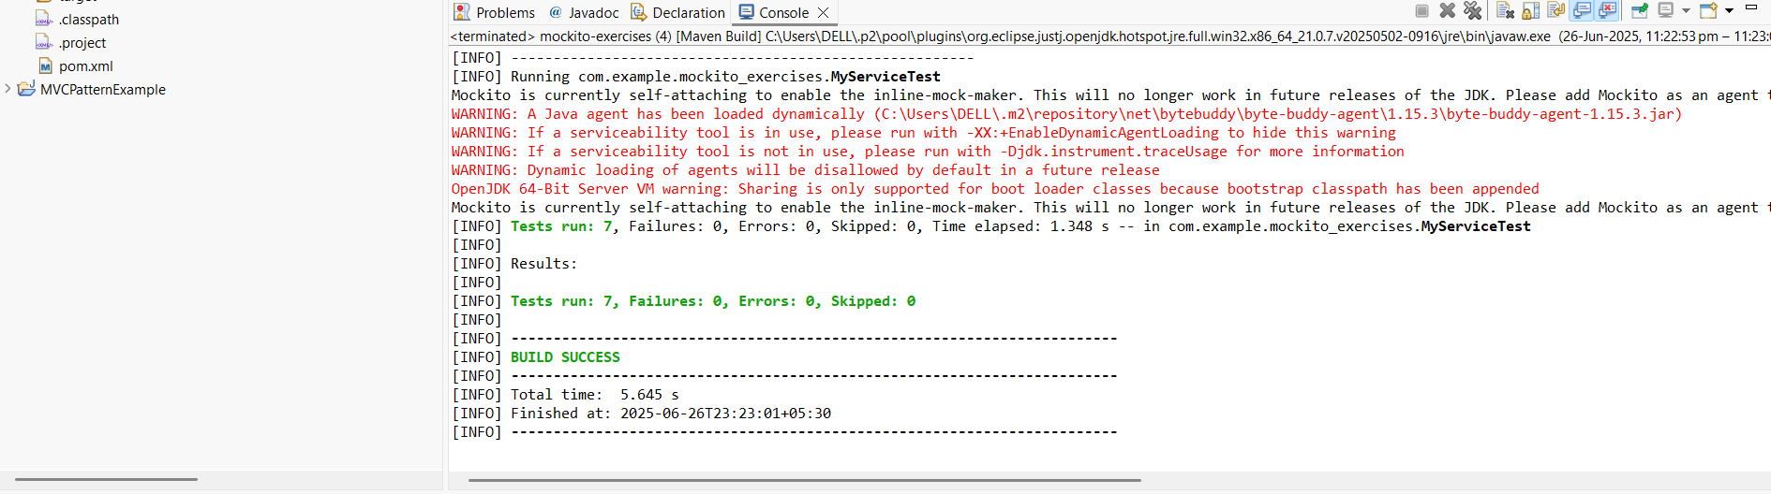

Exercise 2: Verifying Interactions

Scenario: You need to ensure that a method is called with specific arguments.

Steps: 1. Create a mock object.

2. Call the method with specific arguments.

3. Verify the interaction.

Solution Code:

import static org.mockito.Mockito.*;

import org.junit.jupiter.api.Test;

import org.mockito.Mockito;

public class MyServiceTest {

@Test public void testVerifyInteraction()

{ ExternalApi mockApi = Mockito.mock(ExternalApi.class);

MyService service = new MyService(mockApi); service.fetchData(); verify(mockApi).getData(); } }

Output:



Exercise 3: Argument Matching

Scenario:

You need to verify that a method is called with specific arguments.

Steps: 1. Create a mock object.

2. Call the method with specific arguments.

3. Use argument matchers to verify the interaction.

Code:

@Test

**public** **void** testArgumentMatching() {

ExternalApi mockApi = *mock*(ExternalApi.**class**);

MyService service = **new** MyService(mockApi);

service.performAction("specificArg");

*verify*(mockApi).performAction(*eq*("specificArg"));

}

@Test

**public** **void** testVoidMethod() {

ExternalApi mockApi = *mock*(ExternalApi.**class**);

*doNothing*().when(mockApi).performAction(*anyString*());

MyService service = **new** MyService(mockApi);

service.performAction("testArg");

*verify*(mockApi).performAction("testArg");

}

Output:



Exercise 4: Handling Void Methods

Scenario:

You need to test a void method that performs some action.

Steps: 1. Create a mock object.

2. Stub the void method. 3. Verify the interaction.

Code:

@Test

**public** **void** testMultipleReturns() {

ExternalApi mockApi = *mock*(ExternalApi.**class**);

*when*(mockApi.getData())

.thenReturn("First Call")

.thenReturn("Second Call");

MyService service = **new** MyService(mockApi);

String firstResult = service.fetchData();

String secondResult = service.fetchData();

*assertEquals*("First Call", firstResult);

*assertEquals*("Second Call", secondResult);

}

Output:



Exercise 5: Mocking and Stubbing with Multiple Returns

Scenario:

You need to test a service that depends on an external API with multiple return values. Steps: 1. Create a mock object for the external API.

2. Stub the methods to return different values on consecutive calls.

3. Write a test case that uses the mock object.

Code:

@Test

**public** **void** testInteractionOrder() {

ExternalApi mockApi = *mock*(ExternalApi.**class**);

MyService service = **new** MyService(mockApi);

service.performAction("first");

service.fetchData();

InOrder inOrder = *inOrder*(mockApi);

inOrder.verify(mockApi).performAction("first");

inOrder.verify(mockApi).getData();

}

Output:



Exercise 6: Verifying Interaction Order

Scenario: You need to ensure that methods are called in a specific order.

Steps: 1. Create a mock object.

2. Call the methods in a specific order.

3. Verify the interaction order.

Exercise 7: Handling Void Methods with Exceptions

Scenario:

You need to test a void method that throws an exception.

Steps: 1. Create a mock object.

2. Stub the void method to throw an exception.

3. Verify the interaction.

Code:

@Test

**public** **void** testVoidMethodWithException() {

ExternalApi mockApi = *mock*(ExternalApi.**class**);

*doThrow*(**new** RuntimeException("Action failed")).when(mockApi).performAction(*anyString*());

MyService service = **new** MyService(mockApi);

**try** {

service.performAction("testArg");

} **catch** (RuntimeException e) {

// Expected exception

}

*verify*(mockApi).performAction("testArg");

}

}

Output:

